Title
Author(s)
Author Affiliation(s)

Abstract Text (approx. 250 words)
Abstract Text
Abstract Text
Abstract Text
Abstract Text
Abstract Text
Abstract Text
Abstract Text
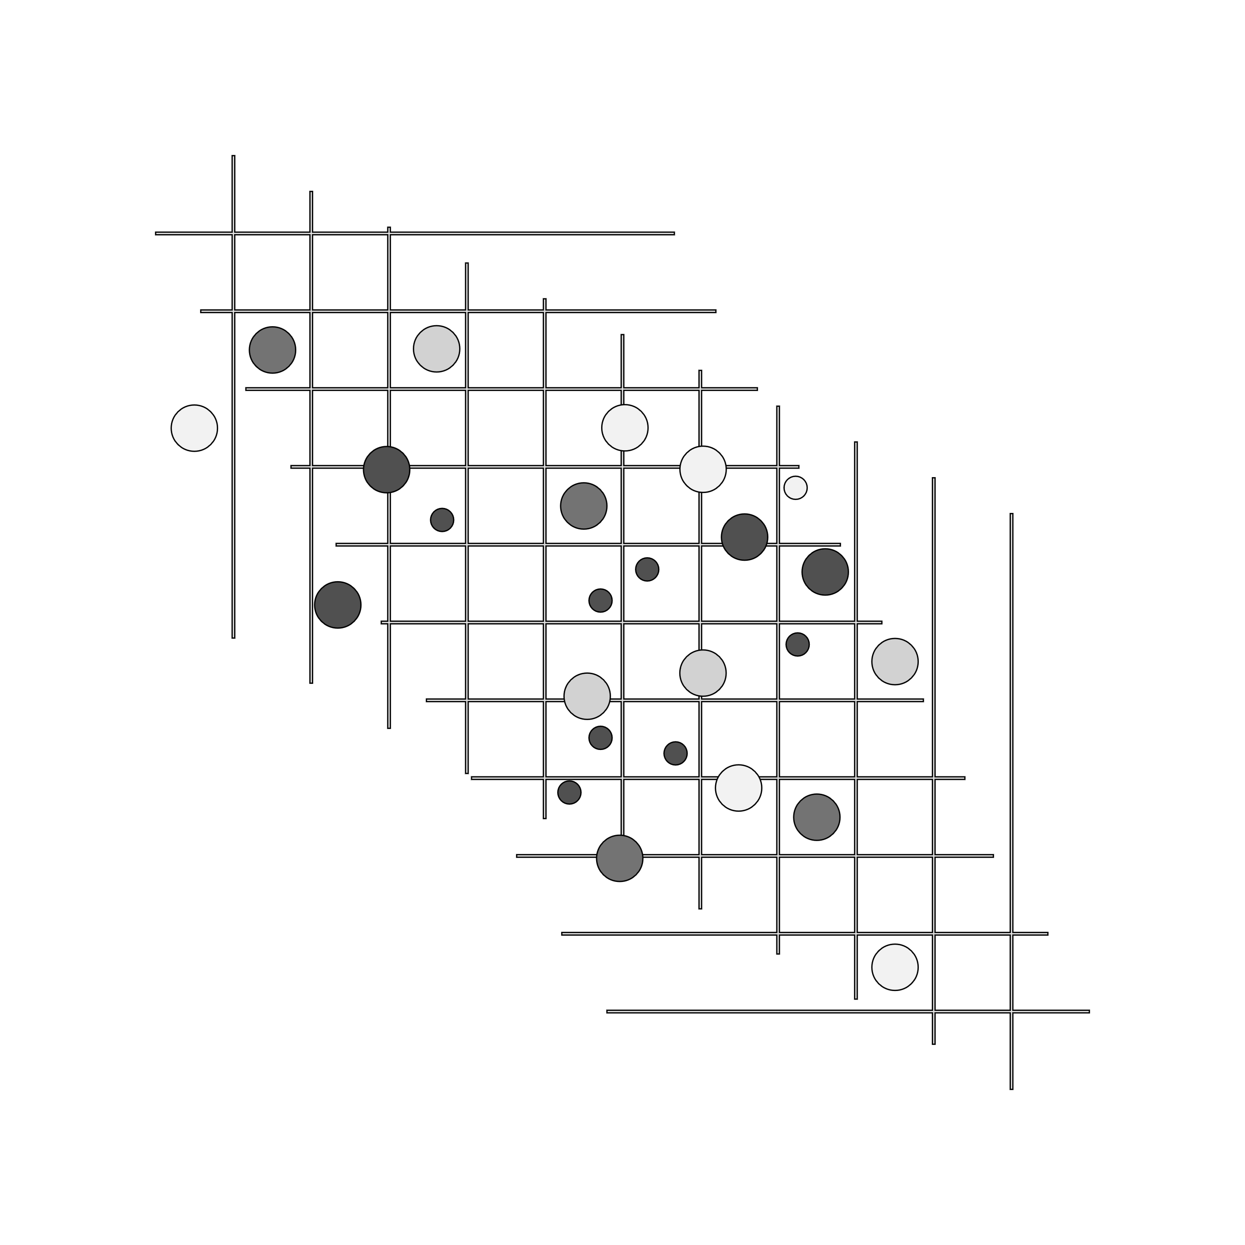
Figure 1. Figure caption text

